Application note 010 rev1,
The intention of this AppNote is to demonstrate a way to find all complex roots of an equation with less hunting for solver starting points on random basis to produce all the roots.
This method (the basis of which was shared to me by Jozef Ongena), is based on the fact that an N-th polynomial can essentially be re-written as: $\prod_{n=1}^{N}{(x - {root}_{n}})$ and that once you have found one root (using the numeric solver), you can divide by that term/factor provided that it is not zero. We can thereby divide by the factor (x – root) formed by using the previously found root: $\frac{\prod_{n=1}^{N}{(x - {root}_{n}})}{(x - {root}_{1})}$ . Should the solver ($x - {root}_{m}$) term/factor reach 0 while solving, the solver already is programmed to deal with asymptotes and internal divide-by-zeroes.
This step converts the original polynomial to one order lower, N-1, by removing that root. Due to the discontinuity of dividing by that factor which is zero at that root, the solver cannot find this root again and it will continue to find a different root. This process is then repeated until all roots are found. Note that you can divide by two factors if roots are found in conjugate pairs, and note that for polynomials with non-complex coefficients, complex roots will be in conjugate pairs. Conversely, roots of polynomials with complex coefficients will include single (non-conjugate pair) complex numbers.
Due to the fact that the method is numerical and does not depend on CAS to analytically divide by a root factor, this method can also be used in some cases where the formula is not directly a polynomial: Simply continue to divide the equation by (x – root) to solve for each next root.
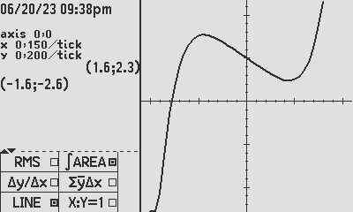
Let us continue from where AppNote 002 was set up, with an equation in EQN which has both complex and real roots: x^5 - x + 1, was defined.
A 5th degree polynomial with real coefficients, is known to have the following possibilities for roots:
- 5 real roots, or
- 3 real roots and one complex conjugate pair of roots, or
- 1 real root and two complex conjugate pairs of roots

- Equation to solve: x^5 - x + 1:
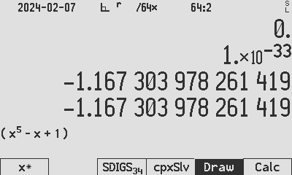
This 5th degree polynomial with real coefficients, looking at the graph, seems to have the following possibilities for roots: 1 x Real + 2 conjugate pairs.

To find the real root, we start the solver near the graphic y=0 point, i.e. we try the range indicated on the graph which is clear for x to be between -1.5 and -0.75. We enter: -1.5 [x] -0.75 [x] [cpxSlv], and we find the real root at Root 1 = -1.167303978261418684256045899854842.

Store it in aa.

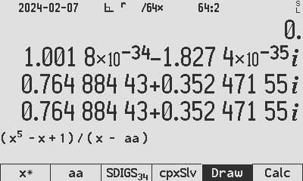
Now to divide by the factor: we will divide the polynomial by (x – Root1), so we edit the equation:
- Equation to solve: (x^5 - x + 1) / (x – aa)

We now have reduced our equation to a 4th order polynomial which will have 4 roots coinciding with the 4 remaining roots we are seeking.

The roots will be complex (as per the 5 roots discussed above), so it will save time make the first guess complex, we arbitrarily use: 1 [x] i [x] [cpxSlv], and we easily find the next root to be one of a complex conjugate pair:
0.7648844336005847260298231877085417 + ⅈ0.352471546031726249317947091402581.

Store it in bb.
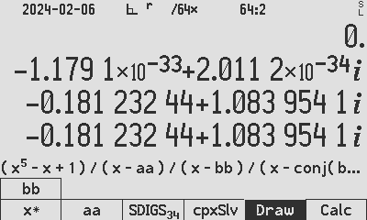
Repeat the procedure to divide the polynomial by the complex pair found above, i.e. (x - Root2)(x - Root3) and edit the equation as follows:
- Equation: (x^5 - x + 1) / (x – aa) / (x – bb) / (x – conj(bb))

We have now reduced our equation to a 2nd order polynomial which will have two roots coinciding with the 2 remaining roots of the original 5th order polynomial which we are seeking.

The roots will be complex as per the original determination and it will save time make the first guess complex, again we arbitrarily use: 1 [x] i [x] [cpxSlv], and we easily find the last complex conjugate pair of roots to be:
-0.1812324444698753839018002377811205 + ⅈ1.083954101317710668430344492980767.
Tip: If you are unsure if a root is part of a conjugate pair, save the root as stated above and use [CPX] [conj] to change the root in X to its conjugate, go back to the equation, press [x] to store this new root in x and press [Calc] to verify if the formula result is 0 for that tested root.

The roots are:
x = -1.167303978261418684256045899854842.
x = 0.7648844336005847260298231877085417 +- ⅈ0.352471546031726249317947091402581
x = 0.1812324444698753839018002377811205 +- ⅈ1.083954101317710668430344492980767
Author Jaco Mostert
Acknowledging Copyright (C) 2023 The C47 Development Team. Permission is granted to copy, distribute and/or modify this document under the terms of the GNU Free Documentation License, Version 1.3 or any later version published by the Free Software Foundation; with no Invariant Sections, no Front-Cover Texts, and no Back-Cover Texts. A copy of the license can be downloaded from gnu.org.

